**FIT3179 Data Visualisation**

**Assignment II**

Gayi (Gracee) Liao 33233357

Website URL:

<https://kitkatug.github.io/Data-Visualisation-II/>

GitHub Repository URL:

https://github.com/kitkatug/Data-Visualisation-II

No. of Words: 907

**Introduction**

The data visualisation, “Touring Around Australia with Airbnb” subjects to the topics of tourism and accommodation in Australia. It focuses on being an informative piece for travellers/tourists while presenting data for those interested in the human flow in Australia.

**What**

The data was obtained from Kaggle (Blanche, 2020) and Inside Airbnb (2023) which were inclusive of all the attributes used in the visualisation. Namely the longitude/latitude, states and regions, prices, number of trips and purposes. Based upon these attributes four categories were defined: location, costs, timeline, and purpose. These were separated from the introduction

**Why & How**

The category, location mainly consisted of longitude and latitude: two quantitative attributes which is determined by the channel position and best represented with a point mark. The idiom chosen that fits these criteria is a symbol map shown in figure 1.

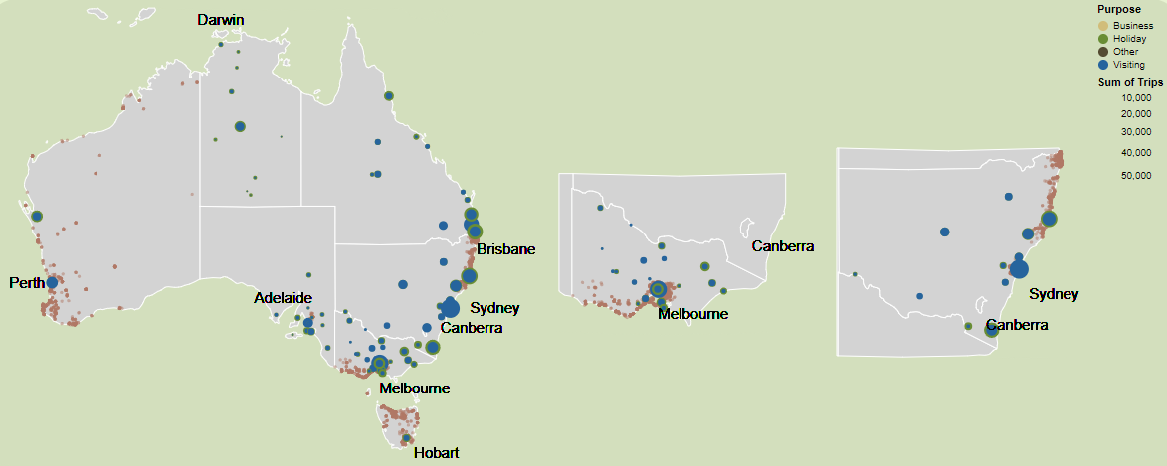Figure 1: Symbol Map

The two quantitative attributes are encoded by three types of channels, colour, size, and position. Where colour represents the purpose and Airbnb’s, while size represents the sum of trips in that area. The position channel shows the location of the trips and Airbnb’s, this allows viewers to compare between the most accommodating travel spots. To enhance the viewer’s experience, closer visualisations of the denser states, Victoria, and New South Wales, are shown with textual annotations to help viewers grasp an idea of location. A selection is available for users to go through each purpose and a toolbox helps them gain more information. See figure 2.

Figure 2: Selection & Toolbox

The second category, costs is presented with a radial plot. While presenting the attributes of price and state, the radius is determined in an orderly fashion so users can see the cheapest and most expensive states. While there are two attributes to this graph, the focus is the price which can be broken down into components (states). So, the best idiom to represent this is a part-to-whole visualisation. (GIJN Staff 2019) See figure 3.

Figure 2: Radial Plot

Here the colour channel is primarily used to convey the states in adjunction to the textual mark which annotates the sections. The radius/size of the section is a channel that allows viewers to compare between the prices.

To increase the informative aspect of the visualisation, the number of trips is represented by a waterfall chart with the attributes of year and total trips. This chart best shows the decrease and increase in tourism through the mark, bar, which is shown by the colour channel hue using, red and green where red is decrease and green is increase. This idiom was chosen due to its blocky appearance and effectuality, where it firstly aligns with the “blocked colour theme” and secondly can strongly differentiate between decrease and increase compared to a line graph or a regular bar graph.

Figure 3: Waterfall Chart

Lastly, to keep the individuality of the states a grouped bar chart was used to define the number of trips by state by purpose. This graph consists of three attributes, purpose, trips, and state and effectively shows the most toured to state as well as the reason why. The colour channel hue effectively differentiates between the states while using the mark bar. For more user interaction, a legend selection (shown in figure 5) can be used to compare between the number of trips by the purpose.

Figure 4: Grouped Bar Chart

Figure 5: Legend Selection

**Design**

**Layout**

The layout is strongly influenced by Gestalt’s principles of enclosure and proximity. Focusing on horizontal sightlines made by the coloured boxes that differentiate between topics, and vertical sightlines to make columns of text that support the graph.

**Colour**

Colour’s chosen in this visualisation are earthy tones, relative to an Australian theme. Starting with the background colour, light and darker green, the darker green encloses the information in each topic following Gestalt’s principle of enclosure. Meaning the objects within this box are grouped together. (Harley, 2020) The colours within the visualisation are kept to 5-8 colours which differentiate between the states as to not to overwhelm the viewer. Colour hues are used to show a nominal attribute such as purposes seen in the symbol map and states seen in the radial plot and bar chart.

**Figure-Ground**

As mentioned before the visualisation mainly uses Gestalt’s principle of enclosure where the white space around the graphs separates each topic. The hierarchy is focused upon the larger/bolder text first, so the title before going downwards to the headings and then the content.

**Typography**

There are two typefaces used in the visualisation – Playfair and Verdana. Playfair was used as the title and headings of each section as the serif font is more legible in a larger scale and differentiates it from the sans-serif body text. Verdana is a lot simpler and easier to the eyes, so more suitable to be used in larger masses. Certain texts in the body paragraphs were bolded in either colour or black, this highlights the main point of these paragraphs. If it was also in colour, it is a linkage between the text and colours within the graphs.

**Story Telling**

The narrative genre used in this visualisation is a magazine format where the storytelling is focused upon the text in the visualisation and is promoted by the graphs and images provided. Textual annotations across the graphs are used to enhance the fluidity of the connections between graphs and text. While the parameters provide user interaction which increases user experience.

**References**

Blanche, L. (2020). Quarterly Tourism in Australia. Retrieved from <https://www.kaggle.com/datasets/luisblanche/quarterly-tourism-in-australia>

(2023). Retrieved from <http://insideairbnb.com/get-the-data/>

GIJN Staff. (2019). Retrieved from https://gijn.org/document-of-the-day-visual-vocabulary/

Harley, A. (2020). Retrieved from https://www.nngroup.com/articles/gestalt-proximity/